**Customer Support Ticket Analysis Report**

**1. Executive Summary**

This report analyzes customer support tickets to identify common issues, measure response and resolution effectiveness, and recommend process improvements for faster and more satisfying customer service.  
**Key insights:**

* **Total resolved tickets analyzed:** 382
* **Average resolution time:** 7.5 hours
* **Average customer satisfaction:** 3.1/5
* **Most frequent issues:** Technical errors, billing inquiries, and account access problems
* **Areas for improvement:** Billing resolution times, satisfaction in Cancellation and Product categories, and precise ticket categorization

**2. Key Findings**

**A. Ticket Distribution and Performance by Category**

| **Category** | **Ticket Count** | **Avg. Resolution Time (hrs)** | **Avg. Satisfaction (out of 5)** |
| --- | --- | --- | --- |
| Account | 18 | 6.9 | 3.6 |
| Billing | 29 | 7.9 | 3.2 |
| Cancellation | 1 | 1.1 | 2.0 |
| Other | 224 | 7.8 | 3.2 |
| Product | 7 | 6.7 | 2.1 |
| Technical | 103 | 7.0 | 3.1 |

* **Highest volume:** "Other" (224) and "Technical" (103) categories
* **Slowest resolution:** Billing (7.9 hours)
* **Lowest satisfaction:** Cancellation (2.0/5), Product (2.1/5)

**B. Common Issues and Complaint Triggers**

* **Technical:** Network/connectivity issues, software errors, account access problems
* **Billing:** Payment issues, refund delays
* **Account:** Password resets, account recovery
* **Other:** Broad category, suggesting a need for better classification

**Word cloud and text analysis** highlighted terms such as "issue," "error," "message," "network," and "account" as most frequent in technical and billing tickets.

**C. Sentiment Analysis**

* **Technical tickets:** Wide range of sentiment, with a significant portion negative or neutral, indicating customer frustration.
* **Overall sentiment:** Mixed, with opportunities to improve customer experience in technical and billing areas.

**3. Process Improvement Recommendations**

To improve response time and customer satisfaction, the following actions are recommended:

**A. Automate Ticket Triage and Routing**

* **Implement machine learning models** to automatically categorize and route tickets to the appropriate team.
* **Prioritize tickets with negative sentiment** for immediate attention.

**B. Expand Knowledge Base and Self-Service Options**

* **Develop FAQs and step-by-step guides** for common technical, billing, and account issues.
* **Introduce chatbots** for frequently asked questions to reduce ticket volume and speed up first response.

**C. Monitor and Optimize Response Times**

* **Set up real-time dashboards** to track first response and resolution times by category and channel.
* **Identify bottlenecks** (e.g., slowest categories, channels) and reallocate resources or automate responses where possible.

**D. Implement Customer Feedback Loop**

* **Send automated satisfaction surveys** after ticket closure to gather customer feedback.
* **Use feedback to refine processes** and agent training.

**E. Refine Ticket Categorization**

* **Expand and clarify category definitions.**
* **Retrain classification models** with more granular tags and sample tickets to reduce reliance on the "Other" category.

**4. Priority Actions**

1. **Focus improvement efforts on Cancellation and Product categories** to address low satisfaction.
2. **Investigate root causes in Billing resolution processes** to reduce average resolution time.
3. **Implement automated solutions for high-volume categories** (Technical, Other) to streamline triage and response.

**5. Conclusion**

By leveraging data-driven insights and automation, your customer support team can significantly improve response times and customer satisfaction. The recommended actions focus on automation, self-service, and continuous feedback to create a more efficient and customer-centric support operation.

**Prepared by:**  
Raziullah Ansari

10-06-2025

**Attachments:**

Visualizations:

1.Common Words in Low-Rated Refund & Technical Tickets

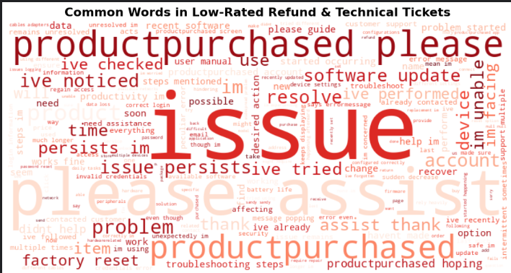

1.Low Satisfaction Tickets by Ticket Type

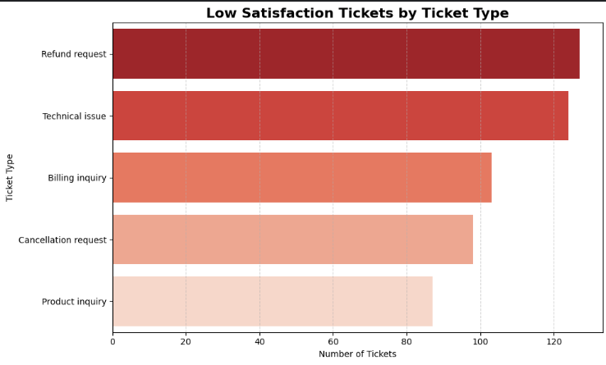

2.Common words in Low-Rated Tickets

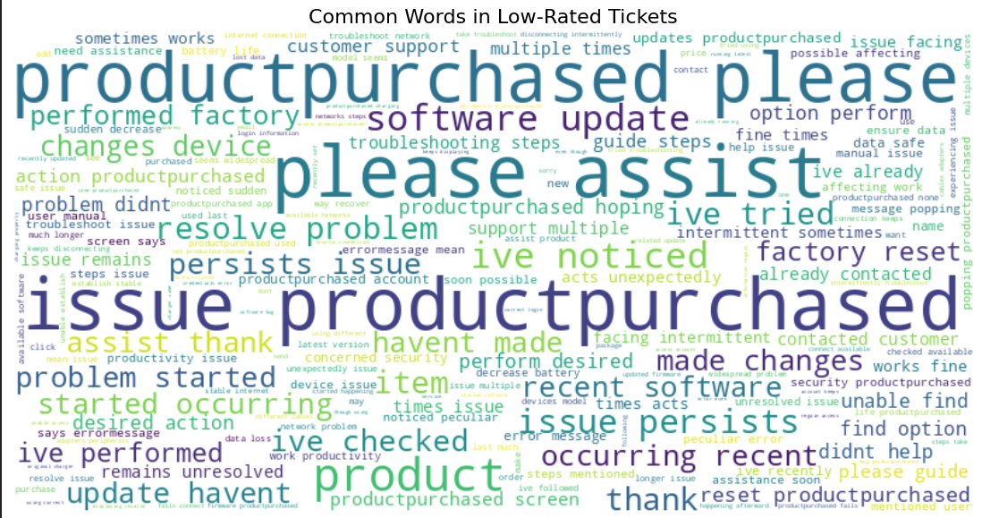

3. Ticket Volume by Type and Avg Resolution Time by Type